IMO MSC-FAL Compliance for Log360
Strengthen cybersecurity and meet IMO MSC-FAL compliance with Log360.
Region: International | Type: Cybersecurity Framework, Maritime | Category: Compliance | Pricing: Free

Overview
The IMO MSC-FAL compliance extension in Log360 helps organizations meet IMO MSC-FAL.1/Circ.3/Rev.3, the International Maritime Organization's guidelines on maritime cyber risk management, mandatory under IMO Resolution MSC.428(98) since January 2021 by providing centralized log management, maritime system monitoring, and cyber incident detection. The platform supports IMO MSC-FAL requirements for cyber risk identification, system protection, incident detection, response and containment, operational recovery, and crew cybersecurity awareness.
For Identify Maritime Cyber Systems and Risk Assets, Log360 inventories Windows and network device assets, tracks system configurations, and monitors virtualization infrastructure to maintain a comprehensive asset register of cyber-connected maritime systems. To address Protect Maritime Systems from Unauthorized Access, the platform monitors logon events, failed authentication, network device access, firewall rules, and MFA usage across Windows, Unix, and network infrastructure to protect maritime operational technology. The extension also supports Detect Cyber Threats and Anomalies by providing capabilities that aggregates antivirus alerts, network attack reports, firewall security events, and threat detection logs from Windows, Unix, and network devices to identify anomalies in maritime systems.

Key Features
- Respond to Maritime Cyber Incidents: Log360 captures system events, process execution trails, audit logs, and attack alerts to provide the forensic evidence and real-time visibility needed for effective incident response on ships.
- Recover Maritime Operations after Cyber Incidents: Log360 monitors backup job status, disaster recovery activities, virtualization restoration, and Windows backup events to validate recovery readiness and operational continuity.
- Identify Maritime Cyber Systems and Risk Assets: Log360 inventories Windows and network device assets, tracks system configurations, and monitors virtualization infrastructure to maintain a comprehensive asset register of cyber-connected maritime systems.
- Protect Maritime Systems from Unauthorized Access: Log360 monitors logon events, failed authentication, network device access, firewall rules, and MFA usage across Windows, Unix, and network infrastructure to protect maritime operational technology.
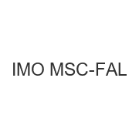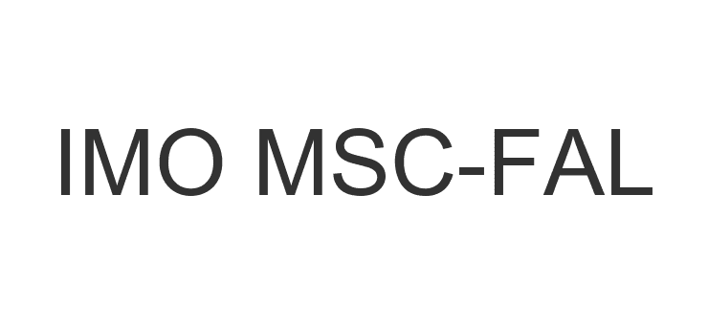
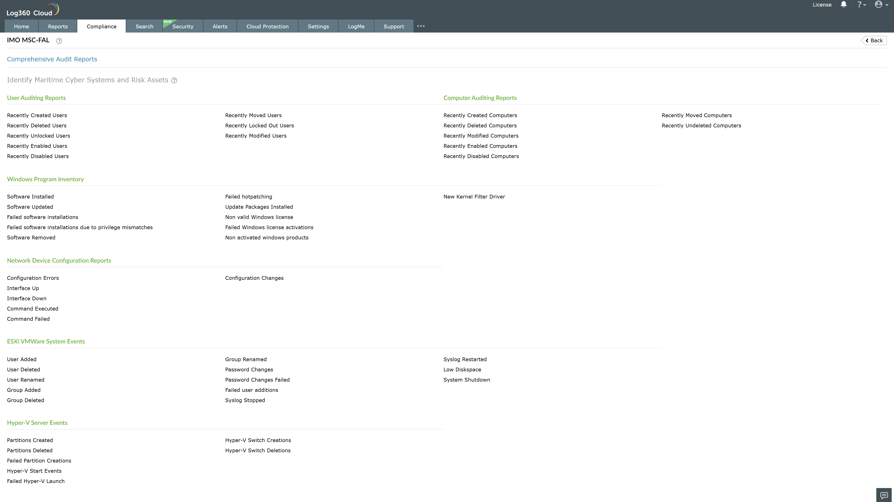
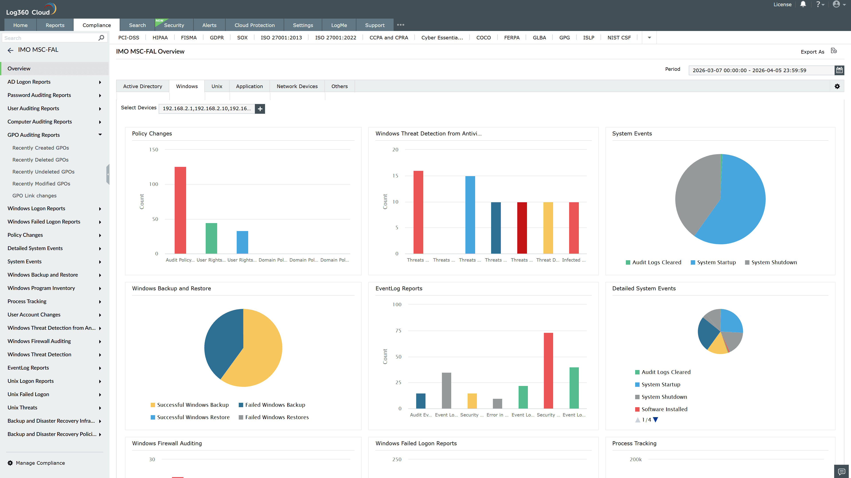
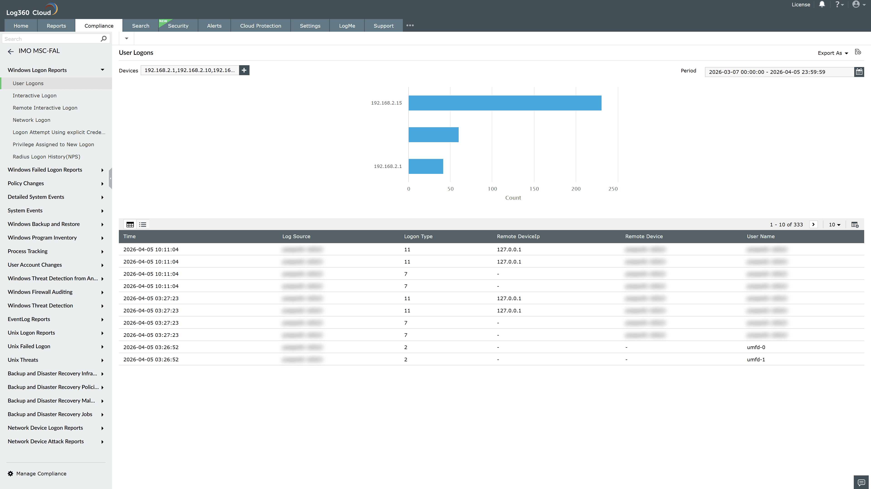
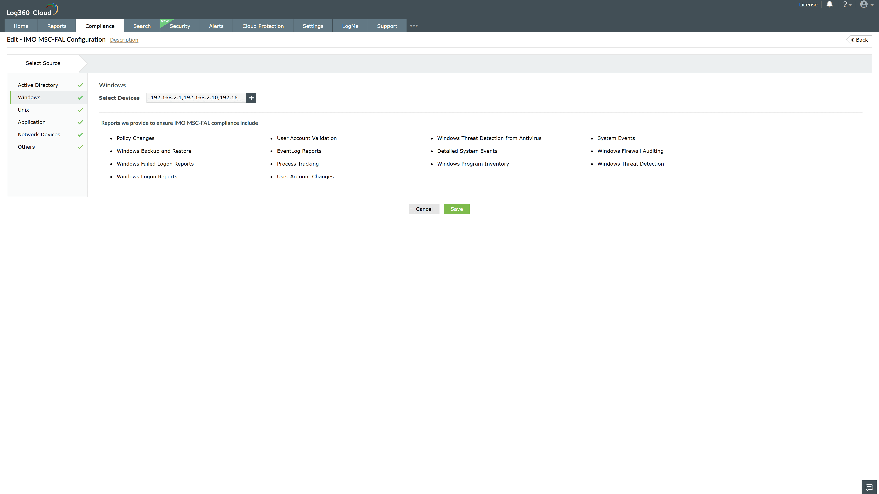
Valid Submission : Yes
Supported Editions : Free, Basic, Standard, Professional, MSSP
Help Document : https://www.manageengine.com/log-management/help/integrations/compliance-extensions.html
Help Video : Not provided
Tags : Log360, Compliance, Privacy monitoring, Data privacy, Regulatory compliance
Supported DCs : US, IN, JP, CA, AU, UK and EU
Privacy Policy:
Terms of Service:
Release Notes:
Predefined reports for the IMO MSC-FAL.

